
Lesson 10: Play It Again
TIC-80
VIDEO GAME CREATION
This week: when the round ends, the game actually stops - and pressing R brings it back to a genuinely fresh start.
Open your own [YourName]Game project from Lesson 9 - don't start a new one.
Tip: no new assets this week - this is a logic lesson, and it reuses your very first setup code from Lesson 5.

Setup
- Launch TIC-80 and load your cart from Lesson 9.
- Press Esc to reach the code editor.

Level 1 - Minimal (MVP)
When the round ends (win or lose), the game freezes - score and lives stop changing, and further enemy hits/escapes do nothing. Pressing R resets everything and starts a new round.
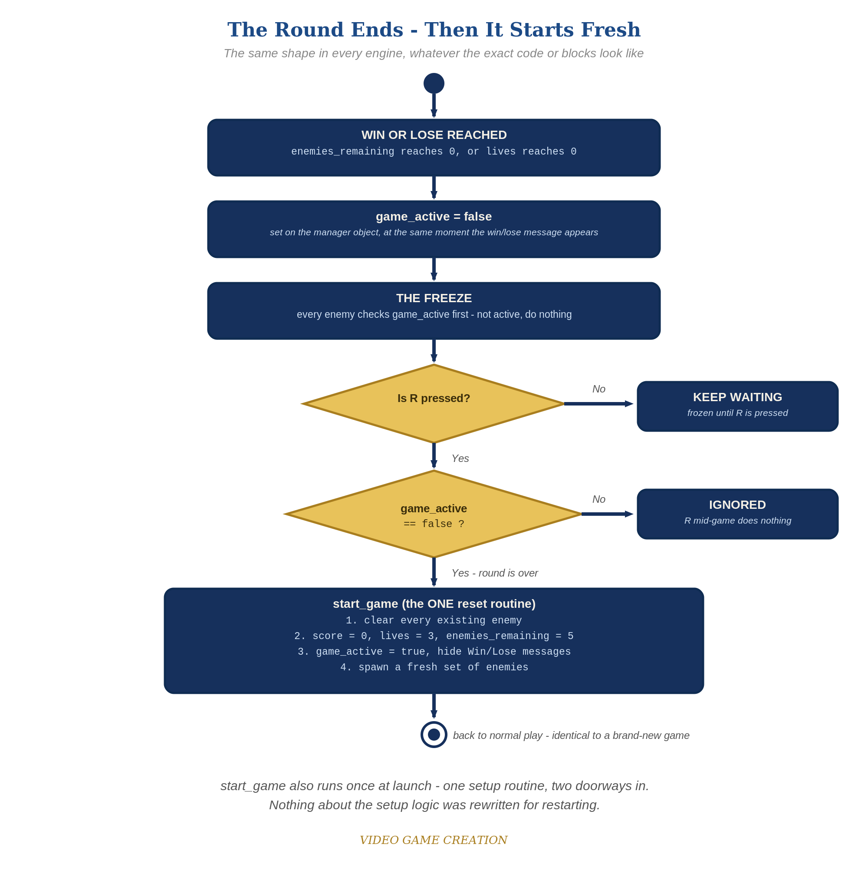
When the round ends, everything freezes - and R, pressed only while the round is over, runs the one reset routine. The same shape in every engine.
- Add game_active=true near the top of your code, with your other game state (score, lives, enemies_remaining).
- Find your existing one-time setup code (populating the enemies table, setting lives, score, enemies_remaining). Move it into a new function start_game() (code below), called once at the top level in place of the old inline setup.
- In the enemy-drawing loop, wrap the movement and escape code in "if game_active then ... end" - this freezes movement once the round ends.
- In the bullets loop's hit branch and the enemy loop's escape branch, when enemies_remaining or lives reaches zero, also set game_active=false, and change the print() text to include the restart hint.
- At the bottom of TIC(), add a check using keyp(18) (TIC-80's key code for R) that calls start_game() if game_active is false (code below).
- Press Esc, type run, press Enter, then play to a win or loss, confirm movement freezes, then press R and confirm everything resets and play resumes.
Highlighted lines are new this week; everything else is code you already have.
-- player position x and y are set above this, exactly as in earlier lessons
game_active=true
function start_game()
enemies={}
for enemy_count=0,4 do
table.insert(enemies,{ex=20+enemy_count*20,ey=10,alive=true})
end
bullets={}
score=0
lives=3
enemies_remaining=5
game_active=true
end
start_game()
function TIC()
cls(0)
if btn(3) then x=x+1 end
if btnp(4) then
table.insert(bullets,{bx=x,by=y})
end
for bullet_index=#bullets,1,-1 do
local b=bullets[bullet_index]
b.by=b.by-2
local hit=false
for enemy_index=1,#enemies do
local e=enemies[enemy_index]
if e.alive and b.bx<e.ex+8 and b.bx+8>e.ex and b.by<e.ey+8 and b.by+8>e.ey then
e.alive=false
enemies_remaining=enemies_remaining-1
score=score+10
if enemies_remaining<=0 then game_active=false end
hit=true
end
end
if hit then
table.remove(bullets,bullet_index)
elseif b.by<0 then
table.remove(bullets,bullet_index)
else
spr(2,b.bx,b.by,0)
end
end
for enemy_index=1,#enemies do
local enemy=enemies[enemy_index]
if enemy.alive then
if game_active then
enemy.ey=enemy.ey+0.3
if enemy.ey>136 then
enemy.alive=false
lives=lives-1
if lives<=0 then game_active=false end
end
end
spr(3,enemy.ex,enemy.ey,0)
end
end
spr(1,x,y,0)
print("Score: "..score,5,5,12)
print("Lives: "..lives,5,15,12)
if enemies_remaining<=0 then
print("You Win! Press R to Restart",50,60,12)
end
if lives<=0 then
print("Game Over - Press R to Restart",40,60,8)
end
if keyp(18) and not game_active then
start_game()
end
end

Level 2 - Complete (Alpha/Beta)
A restart is a genuinely clean slate - no leftover enemies, no stale score/lives, and it works correctly no matter how many times in a row you play.
- Play to a win, confirm movement freezes, then press R and confirm score/lives/enemies_remaining are exactly back to 0/3/5 with no leftover live entries in the enemies table.
- Repeat for a loss - same clean reset.
- Press R while the game is still active and confirm NOTHING happens - the "and not game_active" check is what prevents an accidental reset.

Level 3 - Refined (Ready to Publish) - pick any that interest you
- Visual: briefly flash the screen (cls() with a different color for one frame) the moment game_active flips to false.
- Structure: notice start_game() is now the single place that sets up a fresh game - called once when the cart first loads, and again from inside TIC() on every restart. No setup code is duplicated anywhere.

If Something's Wrong
- Restart does nothing when you press R: confirm you're using keyp(18) (edge-triggered, fires once per press) rather than key(18) (fires every frame the key is held) - using key() here would call start_game() repeatedly while R is held.
- Restart leaves old enemies on screen: confirm start_game() actually replaces the enemies table with a fresh one (enemies={}) rather than trying to modify the old one in place.
- Enemies still move after game-over: confirm the "if game_active then ... end" wrapper actually surrounds the movement/escape code inside the enemy-drawing loop, not just the drawing (spr()) call.

Want More?
Student Resource List > TIC-80 section, or tic80.com

